Jordin Tootoo- Ordering Integers

Subject: Mathematics Creator: Alison Kimbley
Strand: Number Grade: 6
Content (topic)

Ordering Integers
Outcomes  N6.6 Demonstrate understanding of integers concretely, pictorially, and symbolically. | Indicators  N 6.6d: Represent integers concretely, pictorially, or physically.  N 6.6e: Order a set of integers in increasing or decreasing order and explain the reasoning used.  N 6.6g: Extend a given number line by adding numbers less than zero and explain the pattern on each side of zero.
Lesson Preparation
Equipment/materials:
- Map and weather data for Rankin Inlet, Nunavut
- Activity sheet
Advanced Preparation:
- A copy of the worksheet for each student. (Appendix C)
- Have the temperature table displayed so that all the students can see it. (Appendix B)
Presentation
Development
- Provide the class with a short history on Jordin Tootoo. This can be done by explaining that Jordin Tootoo became the first Inuk to play in an NHL game and is a role model for many youth
- He is known for giving a full effort on the ice even though he only stands at 5'-9" tall, making him one of the NHL's shortest players. Jordin is proud to be Inuit and often highlights the rights of Inuit people on their land, the federal government's description and recognition of Indigenous peoples, racism and the higher incidence of Aboriginal youth suicide. Not only is he admired for his hockey skills but also the way he uses his fame to draw attention to many of the issues in his community.
- Jordin Tootoo's home is in Rankin Inlet, Nunavut. In the 2011/2012-hockey season as a member of the Nashville Predators, he will be playing in many cities. Among these are Anaheim California, Dallas Texas, Uniondale New York, Ottawa Ontario, Pittsburgh Pennsylvania and Denver Colorado. (See Appendix A)
- Give each student a worksheet. (Appendix C)
- Students will be looking at ordering integers when looking at temperature.

Appendix A

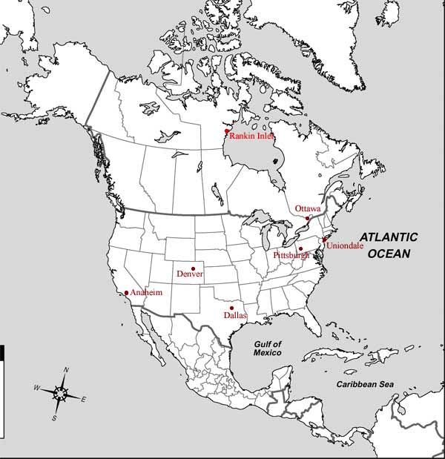

Appendix B
Temperature Table

Average temperature in Rankin Inlet Nunavut in degree Celsius (C)

Month | Average Temperature  (Degrees Celsius)
November | -18
December | -27
January | -32
February | -30
March | -25
April | -17

Appendix C
Activity Sheet
- For the number lines in problems 2, 3, 4, 5, 7 and 8 of this exercise label the tic marks for -10, -20, -30 and -40.

- The Nashville Predators will be visiting the Anaheim Ducks on November 9th, in Anaheim. The average temperature in Anaheim in November is 21º C. On the number line below plot the average temperatures for Anaheim and Rankin Inlet in November and find the difference between the two temperatures.

- The Nashville Predators will be visiting the Dallas Stars on December 23rd where the average temperature is 13º C. On the number line below plot the average temperatures for Dallas and Rankin Inlet in December and find the difference between the two temperatures.

- The Nashville Predators will be travelling to Uniondale, New York to play the Islanders on January 16. The average temperature in Uniondale in January is -1º C. On the number line below plot the average temperatures for Uniondale and Rankin Inlet in January and find the difference between the two temperatures.

- The Nashville Predators will be playing in Ottawa against the Senators on February 9th. In February the average temperature in Ottawa is -8º C. On the number line below plot the average temperatures for Ottawa and Rankin Inlet in February and find the difference between the two temperatures.

- When the Nashville Predators played against the Pittsburgh Penguins in Pittsburgh Pennsylvania on March 22nd Jordin noted that the temperature in Pittsburgh was 35º C higher than in his home town of Rankin Inlet. Plot the average temperature in Rankin Inlet in March on the number line and determine Pittsburgh’s temperature based on this 35º difference.

- The Nashville Predators will visit Denver to play the Colorado Avalanches on April 7th. In Denver the average April temperature is 17º C. On the number line below plot the average temperatures for Denver and Rankin Inlet in April and find the difference between the two temperatures.

- Using the temperature table for Rankin Inlet plot the 6 temperatures on the number line below.
  - Which month has the lowest average temperature?
  - Which month has the highest average temperature?
  - What is the difference in temperature between the lowest and highest?

